# Staff Report

Meeting Date: September 19, 2023

To: Siskiyou County Board of Supervisors

From: Bernadette Cizin, Assistant Planner

Subject: Proposed Outpost M-R LLC Agricultural Preserve Amendment, Williamson Act Rescission with Re-entry, Agricultural Preserve Amendment (APA-23-12) and CEQA Determination

## Background and Discussion

On March 15, 2023, the County received an application for a Boundary Line Adjustment. After the initial review it was found that a Williamson Act Contract amendment would be required as the project proposed to transfer 2.15 acres between two separate parcels, each encumbered by separate Williamson Act Contracts. The applicant amended the application to include an Agricultural Preserve Amendment to the project description and requests that each resultant parcel of the boundary line adjustment be granted a separate contract with the primary use of livestock grazing.

During the review process staff found that one of the subject parcels was only partially within an Agricultural Preserve. The applicant was notified, and it was proposed that the inclusion of the remainder of the parcel in the Agricultural Preserve be considered not a significant increase, as allowed by County guidelines under Section III, Item A. This section allows for an increase in the size of an existing agricultural preserve if advised by the Administrator and determined by the Board on a case-by-case basis.   
This proposal would increase the Agricultural Preserve and corresponding contract by 193.7 acres, approximately 7.5% of the legal parcel.

The subject property has been used for and continues to be used for livestock grazing. The property is leased to Belcampo Farms is part of their grazing rotation for approximately 500 cow/calf operation.

**Agricultural Preserve Administrator Review**

Staff prepared a detailed report (Exhibit C) for review and recommendation by the Agricultural Preserve Administrator. Based on the report, the Administrator found the applicant’s request, including the increase of 193 acres, is consistent with the County Rules for the Establishment and Administration of Agricultural Preserves and Williamson Act Contracts and recommends the Board rescind and reissue the contract, to include 193 acres not previously under contract, as proposed and amend the existing preserve to remove the subject property and establish a new agricultural preserve which includes 193 acres not previously within a preserve.

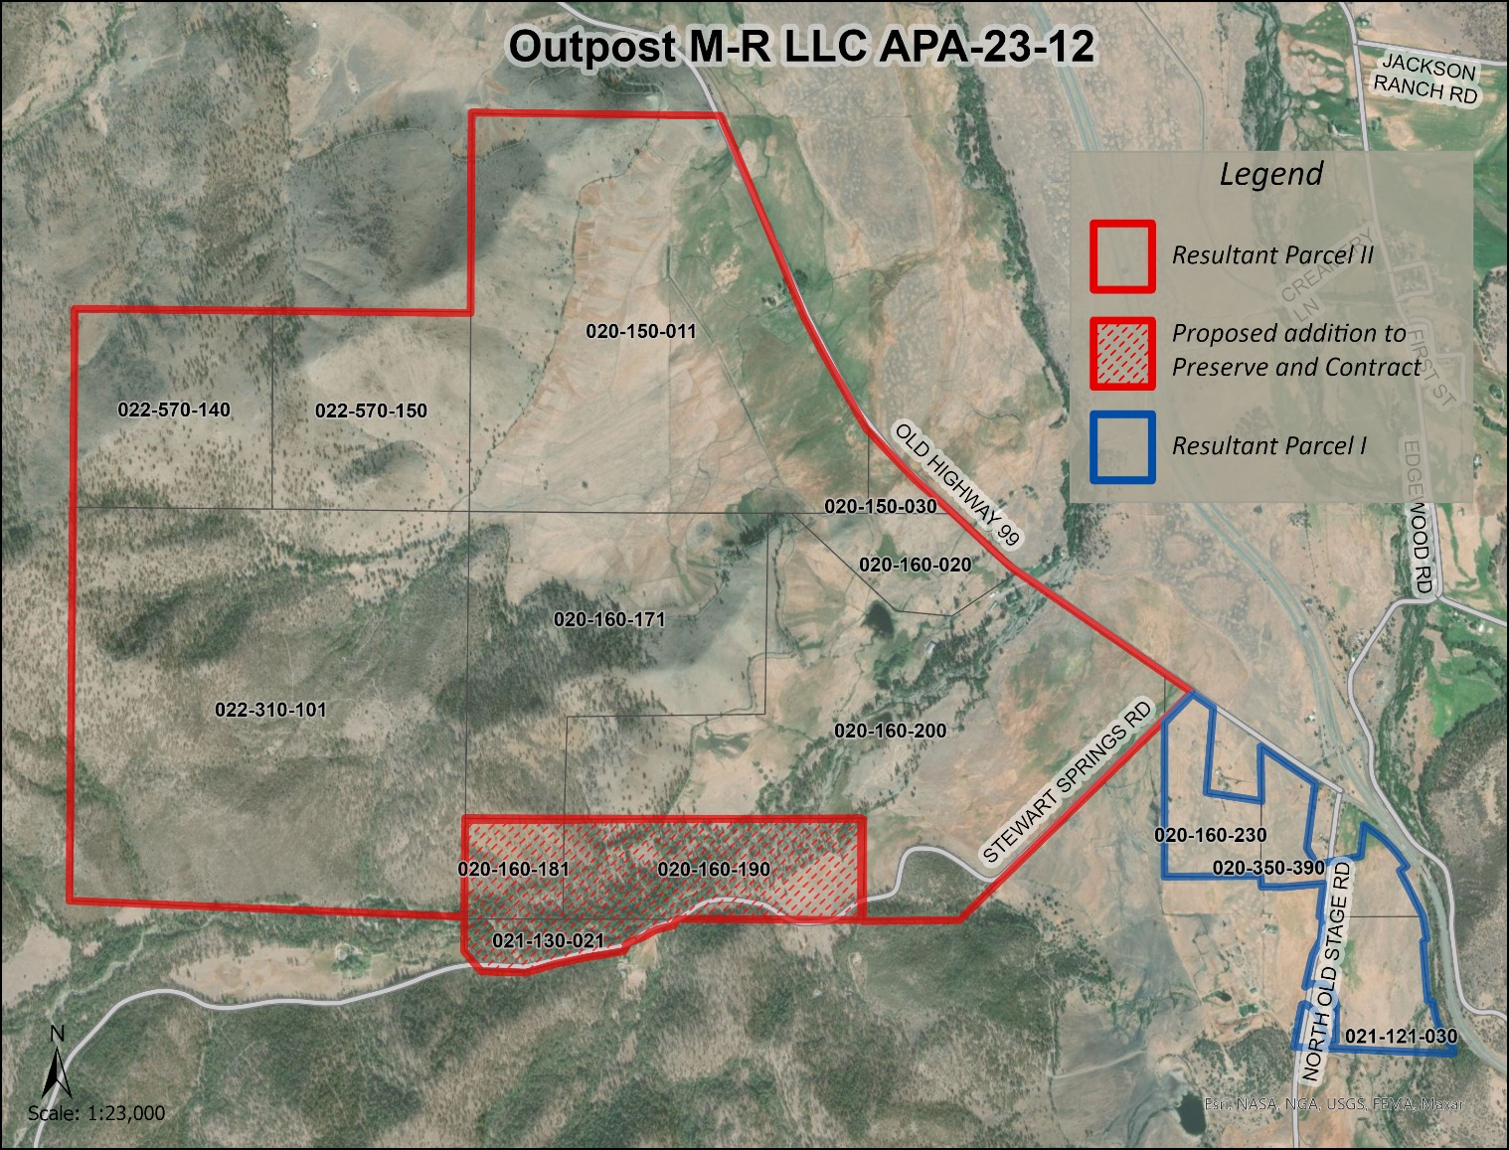   
Figure 1: Subject Parcels

## Environmental Review

Staff is proposing that the proposed project be considered categorically exempt from the California Environmental Quality Act (CEQA) pursuant to CEQA Guidelines Section 15317, *Open Space Easements or Contracts.* A Categorical Exemption implies that the project will not result in any significant adverse environmental effects. CEQA Guidelines Section 15317 specifically exempts the making and renewing of open space contracts under the Williamson Act, which is applicable to the subject action.

The Board of Supervisors must consider the proposed CEQA exemption together with any comments received during the public review process. Further, the exemption can only be approved if the Board finds, based on the whole record before it, that there is not substantial evidence that the project will have a significant effect on the environment. Accordingly, a finding to this effect has been incorporated into both draft resolutions prepared for the Board’s consideration.

## Comments

Agency Comments

***Siskiyou County Assessor – September 8, 2023***

The Assessor’s office has provided estimated tax assessment values for the three parcels included in this project (Exhibit D).

Public Comments

Notice of the project was published and posted as required prior to the Board of Supervisors meeting and no public comment was received as of the preparation of this staff report.

## Recommended Action

Should the Board of Supervisors concur with staff’s analysis, staff recommends that the Board of Supervisors find that the proposed modifications to the Williamson Act contract and Agricultural Preserve are exempt from CEQA and approve said modifications.

A draft motion to this effect is provided below.

## Recommended Motions

I move to take the following actions:

1. Determine the project exempt from CEQA in accordance with Section 15317, Open Space Easements or Contracts; and
2. Adopt the attached resolution approving amendment to the existing Agricultural Preserve and establishment of a new preserve which includes the 193 acres previously not within a preserve; and
3. Adopt the attached resolution approving the rescission and reentry of the applicable Williamson Act contract which includes the 193 acres previously not encumbered by contract; and

## Exhibits to the Staff Report

1. Draft Resolution amending the existing Agricultural Preserve and establishing a new preserve
2. Draft Resolution Approving the Rescission of the subject property from the existing contracts and Reentry into a new Williamson Act Contract
3. Exhibit A within Draft Resolution: Williamson Act Contract Resultant Parcel One – Draft
4. Exhibit B within Draft Resolution: Williamson act Contract Resultant Parcel Two- Draft
5. Agricultural Preserve Administrator Staff Report with Recommendation
6. Comments